**EC601 Replacement Exam Report**

Zhang Ting

ID: U60112569

[zhangting.199612@gmail.com](mailto:zhangting.199612@gmail.com)

Option Chosen: 3. Kaggle Steel Defect Detection

**Abstract**

This research and design report mainly focus on the description of product concept, user stories, minimum viable product design, system architecture, testing strategy and the product’s possible alternatives. This product is mainly designed to replace the human labor in the industry to detect whether there are defects on the steel surface and make the classification as well as localizing them out. Several methods for localization and classification are compared and balanced during the literature review. Wavelet reconstruction and binary threshold segmentation are chosen for the localization, and Principal Component Analysis feature extraction and Self-Organizing Map classifier are chosen for the classification, and other methods are regarded as alternatives.

**Key words:** Defect, Automatic Detection, Localization, Classification

**Introduction**

Quality is a key factor in steel production industrial. Nowadays, the huge world demands require the steel production rate to increase. However, most of the steel quality assurance in the factory are finished by manual inspection, which is slow and unreliable. Manual inspection, even though very accurate in case of few samples, is low-efficient to report errors in such high-speed modern setups. This results in many additional costs which make this approach not only too expensive but also inapplicable. Automated machine vision inspection, one of the most investigated areas in the field of quality assurance, is a fast and reliable detection method.

**Data Set**

Severstal provides 1G training images and testing images.



Normal



Defective



Defective

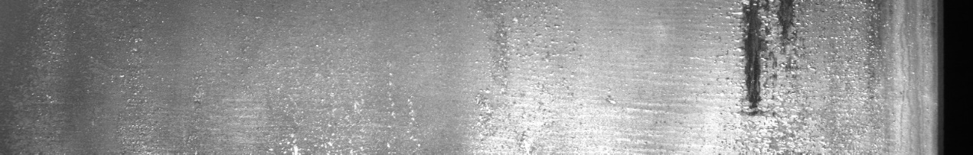

Defective

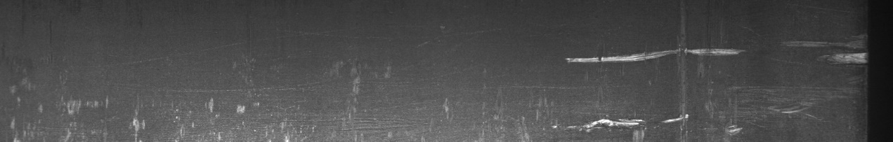

Defective

**Product Concept**

Based on the competition description in the website of Kaggle Severstal Steel Defect Detection, the main goal of the competition is to help develop an algorithm for localization and classifying the defects on a steel sheet. The algorithm is operated on the steel pictures captured by high frequency camera in the factory. Thus, our product design should mainly focus on three questions: (1) Is there any defects on the steel surface? (2) If any, where are they? (3) What kind of defects they are? So, in order to answer these three questions, we could develop our product concept as below:

From the high frequency camera of the factory, we get the input images we want to detect. We don’t know whether there is any defect in the image region. General image data preprocessing methods will firstly be applied to the input images to reduce the effect of distortion and eliminate the noise in the images. After making the input images clear and accurate enough to detect, our product will work on the interested regions with a specific grid size in the image to find the regions that the defects may occur. In training image dataset, the defect region is labeled with their specific defect type and these regions are defined as defective regions. After training the model based on these sub-regions with the labels normal or defective, we could predict the specific region using this model. This trained model could help the users predict on the preprocessed test images and the defective regions are also highlighted out. Finally, the information of the prediction will be presented to the user in UI.

**User Story**

As a user, several requirements should be satisfied:

1. Whether there is any defect existing in the image
2. The user should know where the defect locates in the image
3. The user should know what kind of the defect is
4. The system should be reliable for the users
5. This user case defines the fundamental outcome of the algorithm: whether there is a defect or not.
6. The localization requires the system outline the rough profile of the defect and it will be much more visualized for users to view the defects
7. There can be various types of defects occurring in the image. Some simple geometric defect shape can be a simple line or circle like clamp, scratch and welding. Complex defect shapes include oxidation, exfoliation, texture-like defects. In order to figure out which kind the defect is, the classification for the defect type is necessary.
8. The reliability of the system is critical, since it should guarantee that no critical defect will go undetected, but without generating many false alarms that make the system unusable. The user needs a reliable system that could provide him with a high accuracy.

**Minimum Viable Product**

My minimum viable product should be able to execute both training and testing operations. MVP will do some preprocessing operations like morphological filtering and edge detection first to eliminate the noise and thus increase the later prediction accuracy. Then the preprocessed images will be divided into several blocks with specific pixels size and the blocks of interest are chosen by algorithm. These chosen blocks are labeled and contribute to the training of the model. PCA realizes the feature extraction of the block and SOM realizes the classification of each block. The well-trained model will finally give out the prediction for each block and highlight the blocks with different colors according to their defective type.

**System Architecture**

Input Image

Morphological Filtering

Thresholding Edge Detection

Simple Shape Detection

Region of Interest Detection

Region of Interest Selection

Labeled Image

PCA Feature Extraction

SOM Training

PCA Feature Extraction

SOM Classification

Description of the system architecture:

Phase 1. Morphological Filtering: The Gaussian and Morphological filters are operated on the image to form a gray scale image and eliminate the effect of noise

Phase 2. Thresholding Edge Detection: Threshold edge detection method is applied to segment the gray level image. The image is transformed to a binary image which is clear to detect the interested region in the later phase.

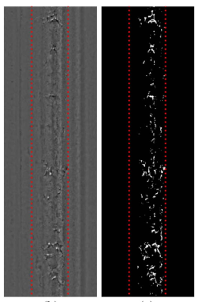

Figure 1. Transform to Binarized Image

Phase 3. Simple Shape Detection: The binary image produced in the phase 2 will be submitted to phase 3. Hough transform is used in this phase to detect simple shape like straight-line and circle defects. These kinds of defects are predicted to the output module and be labeled as specific defect type as long as this line & circle detection is successful.

Phase 4. Region of Interest Detection: A window with a specific size like 32 x 32 pixels will slide through the whole binarized image. Each 32 x 32 region chosen out by this window will be an independent sub-image with 32 x 32 pixels. Among these regions, the region with a quantity of total pixels over a threshold and without any line & circle will be the chosen to next phase and be the candidate for the training. These regions are called region of interest, and they may contain the defects.

Dividing the image into several sub-images could make it easier to extract features out of local regions without losing so many important information. Also, dividing into blocks makes the localization clearer and more accurate.

Phase 5. Region of Interest Selection: The location information of these region of interest chosen in the phase 4 will be recorded and saved. Then the system will crop the corresponding regions from the image after phase 1 filtering. These regions will be used for both training and predicting.

Phase 6. (Training) Labeled Image: The regions of interest chosen from the former phase are labeled as defective or normal for training. If it is defective, the corresponding defect type is also labeled.

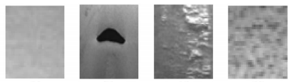

Figure 2. Normal and Defective Labeled Sub-images

Phase 7. (Training) PCA Feature Extraction: Use PCA (Principal Component Analysis) to extract the features out of the regions. PCA is a method that could both reduce the data dimensions and also keep the critical features of the data. Our product chooses PCA since it can be applied easily by using sklearn API and extract features well without losing important information.

Phase 8. (Training) SOM Training: SOM--- Self-Organizing Map is clustering method that could be used as a grouping classification way. The feature vectors with the defective labels are trained by SOM and form a model that could be used later.

Phase 9. (Testing) PCA Feature Extraction: This phase is similar as the phase 7. The regions of interest are chosen from the phase 1 and feature vectors are extracted out to be used for classification.

Phase 10. (Testing) SOM Classification: The well-trained SOM model will detect the defects and predict their type if the defects exist based on these sub-images. The sub-images with the defects detected will be highlighted by specific colored block boxes corresponding to their defect types. The examples are shown as below:

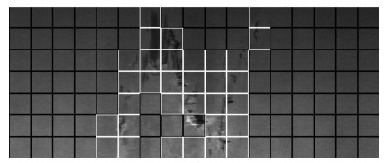

Figure 3. N-shape Defect

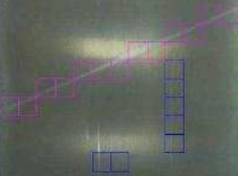

Figure 4. Line Defect

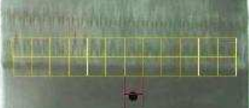

Figure 5. Waveform Defect

**Testing Strategy**

In order to meet the users’ requirement, our product needs to consider several coefficients like precision, recall and their combination G-mean and F-mean.

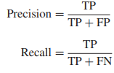

TP: True Positive

FP: False Positive

FN: False Negative

Precision and recall rate should not be so low and our product’s testing goal is to maintain them in a reasonable level.

The formula for the G-mean and F-mean computation:

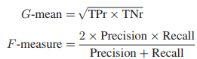

G-mean and F-mean are comprehensive performance evaluation metrics for the testing.

**Alternatives for Machine Learning Approach**

1. The alternative for feature extraction and training/classification model

During my literature research about the method of the feature extraction, I noticed that there is few method about the feature extraction on the steel surface image. Then I begin to think about the similar objects as steel surface. The oxidation and cracks on the steel surface remind me of the fabric and the clothes. I think they are similar, so I search for the feature extraction methods on the textured fabric image. The textured analysis methods are generally usable for the steel defect detection. Discrete Wavelet Transform is one of the famous textured analysis methods. The PCA feature extraction method could be replaced by 2D discrete wavelet transform (DWT). In the computational period of the DWT, we could decompose the 32 x 32 input sub-images into three levels which are vertical level, horizontal level and diagonal level and extract the features out in these three levels respectively.

Also, the training model of SOM could also be replaced by Support Vector Machine (SVM) which creates a hyper-plane that could help classify the defect types.

Total number of articles recommending DWT: 6

[1] *Automatic Defect Detection on Hot-Rolled Flat Steel Products*

[2] *Defect detection for corner cracks in steel billets using a wavelet reconstruction method*

[3] *Vision-based defect detection of scale-covered steel billet surfaces*

[4] *Texture classification and segmentation using wavelet packet frame and Gaussian mixture model*

[5] *Automated surface inspection for statistical textures*

[6] *Stitching defect detection and classification using wavelet transform and BP neural network*

1. The alternative for localization:

Actually, in the field of object localization, RCNN is popular and useful for the multiple object and region localization.

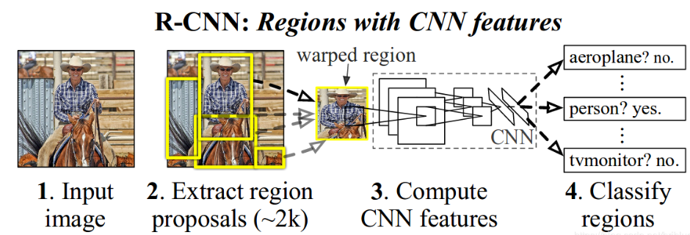

Figure 6. R-CNN

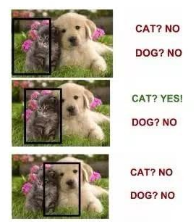

Figure 7. Proposal Region

RCNN is neural network that slides a specific size window through the whole image and select some interested region which produced by Region Proposal Network (RPN). Classifier makes the classification and detection in each proposal region and finally multiple objects could be detected in the whole image. Also, RCNN has developed to Faster-RCNN with better neural network architecture.

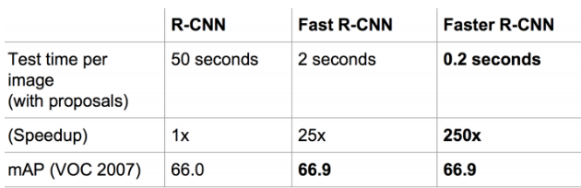

During my literature review, I found a neural network named Mask R-CNN is suitable for our product. It combines both faster-RCNN and instance segmentation together. It has two branches in total, one is for multiple objects detection and the other is for instance segmentation which could outline the location of the defects clearly.

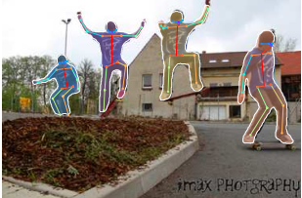

Figure 8. Mask R-CNN

However, consider that our input images are gray scale and don’t have so many vivid features among the whole picture, Mask R-CNN is difficult to work well in our problem as detecting defects on steel surface.

Possessing the abilities of both multiple objects’ detection and instance segmentation, Mask R-CNN could be used as our alternative for the machine learning approach.

Total number of articles recommending RCNN: 4

[7] *Autonomous Structural Visual Inspection Using Region-Based Deep Learning for Detecting Multiple Damage Types*

[8] *Automatic Localization of Casting Defects with Convolutional Neural Networks*

[9] *Detection of Rail Surface Defects Based on CNN Image Recognition and Classification*

[10] M*ask R-CNN*

**References**

1. *Automatic Defect Detection on Hot-Rolled Flat Steel Products.* Santanu Ghorai, *Member, IEEE*, Anirban Mukherjee, *Member, IEEE*, M. Gangadaran, and Pranab K. Dutta, *Member, IEEE*. 2013.
2. *Defect detection for corner cracks in steel billets using a wavelet reconstruction method.* Yong-Ju Jeon,1 Doo-chul Choi,1 Sang Jun Lee,1 Jong Pil Yun,2 and Sang Woo Kim. 2014.
3. *Vision-based defect detection of scale-covered steel billet surfaces.* Jong Pil, Yun SungHoo Choi, Sang Woo Kim. 2009.
4. *Texture classification and segmentation using wavelet packet frame and Gaussian mixture model.* Soo Chang Kim, Tae Jin Kang. 2006.
5. *Automated surface inspection for statistical textures.* Du Ming Tsai, Tse-Yun Huang. 2003.
6. *Stitching defect detection and classification using wavelet transform and BP neural network.* W.K. Wong, C.W.M. Yuen, D.D. Fan, L.K. Chan, E.H.K. Fung. 2009.
7. *Autonomous Structural Visual Inspection Using Region-Based Deep Learning for Detecting Multiple Damage Types.* Young Jin Cha, Wooram Choi, Gahyun Suh & Sadegh Mahmoudkhuni. 2018.
8. *Automatic Localization of Casting Defects with Convolutional Neural Networks.* Max Ferguson, Ronay Ak, Yung-Tsun Tina Lee, Kincho H. Law.
9. *Detection of Rail Surface Defects Based on CNN Image Recognition and Classification.* Lidan SHANG, Qiushi YANG, Jianing WANG, Shubin LI, Weimin LEI. 2018.
10. M*ask R-CNN.* Kaiming He Georgia Gkioxari Piotr Dollar Ross Girshick. 2018.